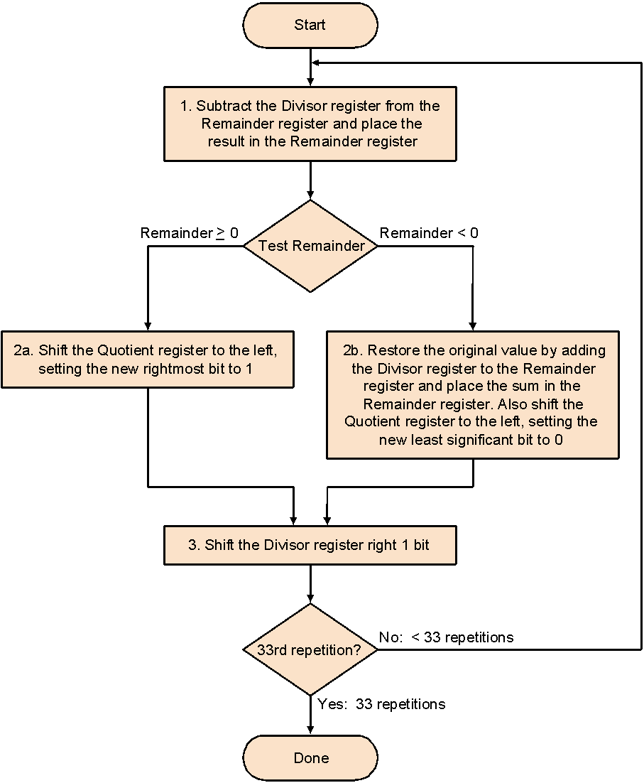

| iteration | steps | Q | D | R |  |
| --- | --- | --- | --- | --- | --- |
| 0 | initialization | 0000 | 0010 0000 | 0000 0111 |  |
| 1 | 1.R=R-LD:  TEST R=? negative  2b. R=R+LD;  LEST SHIF Q  SET Q0=0;  3.SHIFT D RIGHT | 0000 | 0001 0000 | 1110 0111  AFTER RESTORING  0000 0111 |  |
| 2. | 1.R=R-D:  TEST R=? negative  2b. R=R+D;  LEST SHIF Q  SET Q0=0;  3.SHIFT D RIGHT | 0000 | 0001 0000  0000 1000 | 1111 O111  0000 0111 |  |
| 3. | 1.R=R-D:  TEST R=? negative  2b. R=R+D;  LEST SHIF Q  SET Q0=0;  3.SHIFT D RIGHT | 0000 | 0000 0100 | 1111 1111  0000 0111 |  |
| 4 | 1.R=R-LD:  TEST R=? POSITIVE  2A.  LEST SHIF Q  SET Q0=1;  3.SHIFT D RIGHT | 0000  0001 | 0000 001O | 0000 0011 |  |
| 5. | 1.R=R-D:  TEST R=? POSITIVE  2A.  LEST SHIF Q  SET Q0=1;  3.SHIFT D RIGHT | 0010  0011 | 0000 0001 | 0000 0001 |  |
|  |  |  |  |  |  |